Project report
Name – Garvit Agarwal
CTAE College , Udaipur
B.tech (Electronics and Communication Engineering ) 2th year

Project – 1 (energy meter )
- Aim - To design and build an energy meter using Arduino to measure voltage, current, and power consumption.

Components required
- Arduino Uno
- LCD (16x2, I2C)
- Current Sensor (ACS712)
- Transformer
- Diodes
- Resistors, Capacitors
- DC Motor (if used)

Working
- Voltage is stepped down through the transformer
- Then converted to the DC using rectifier
- Current is measured using sensor
- Arduino processes data
- Output shown on LCD
Schematic Diagram
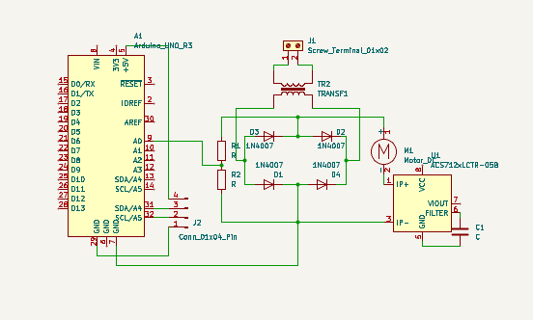

PCB Layout
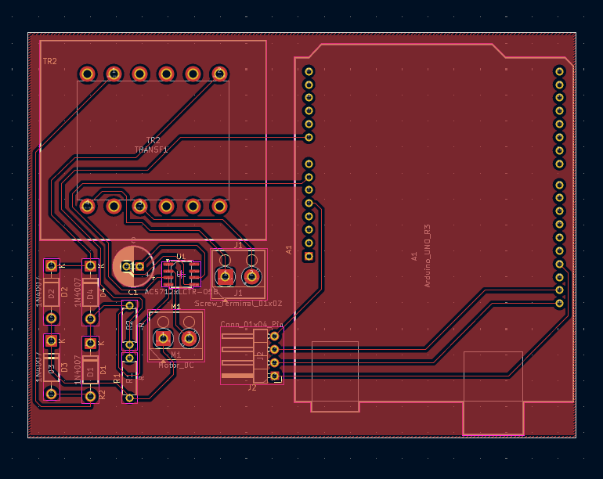

Main Coding concepts
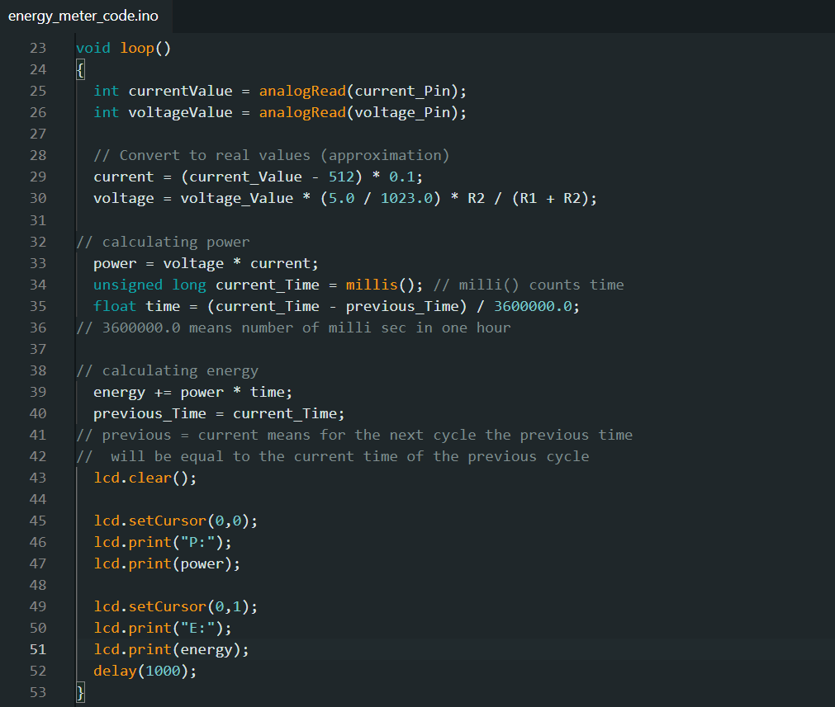
- Current values and voltage values are taken as input
- The they are converted into their real values
- Power is calculated using current and voltage
- Time is measured using millis() function
- Energy is calculated using power and time
- Then both the values are shown on the lcd display

THE testing and building are ongoing

Project – 2 (DC voltmeter)
Aim – To design and build the dc voltmeter using Arduino that measures the voltage of a dc voltage source or battery

Components Required –
- Battery (for testing)
- Breadboard
- Jumper wires
- Arduino uno r3
- 2 resistors – 1 k ohm and 220 ohms

Working
- The DC voltage is given to the voltage divider circuit
- The voltage divider converts it with in the safe range of the Arduino (5v)
- Arduino reads the analog voltage using its ADC (Analog-to-Digital Converter).
- The analog value is converted into actual voltage using a formula.
- The calculated voltage is displayed on the LCD or Serial Monitor.

Schematic Diagram
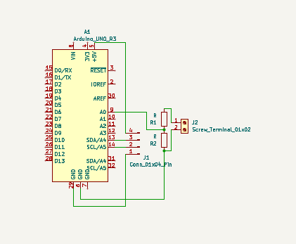
PCB Layout
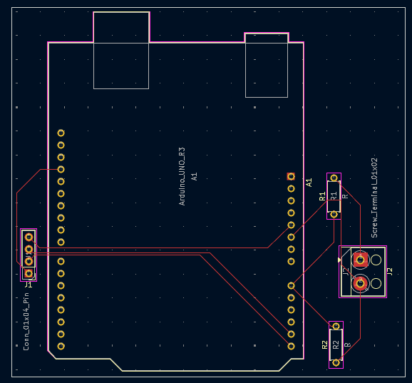

Main Coding Concepts
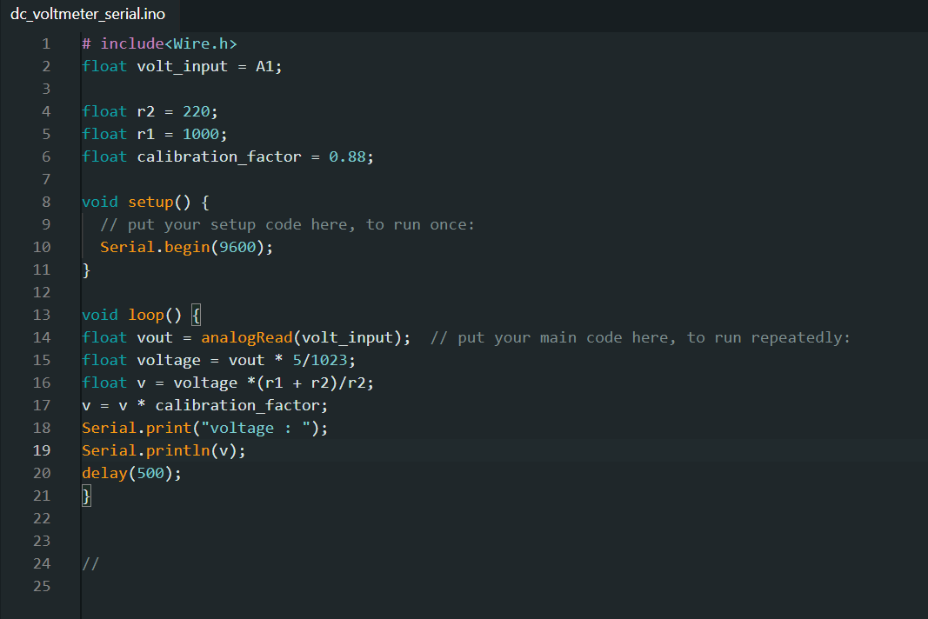
- The value of the resistors given
- Calibration factor is given (in this the multimeter is not used instead considering the previous results the calibration factor is determined )
- Serial monitor is initialized
- The voltage form the divider circuit is taken as an input
- Converts the analog data into the voltage
- Applying the reverse voltage divider , converting back the safe range voltage into its original range
- Calibration factor is multiplied
- And finally the result is printed on the serial monitor

RESULT
The DC voltmeter was successfully implemented using Arduino, demonstrating accurate voltage measurement and display using a simple and cost-effective setup.
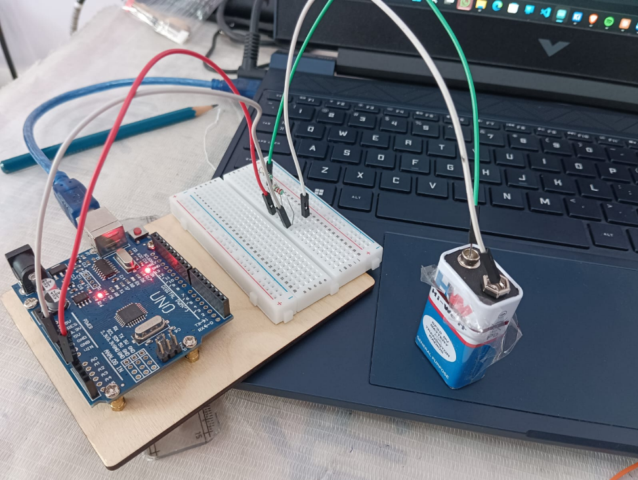
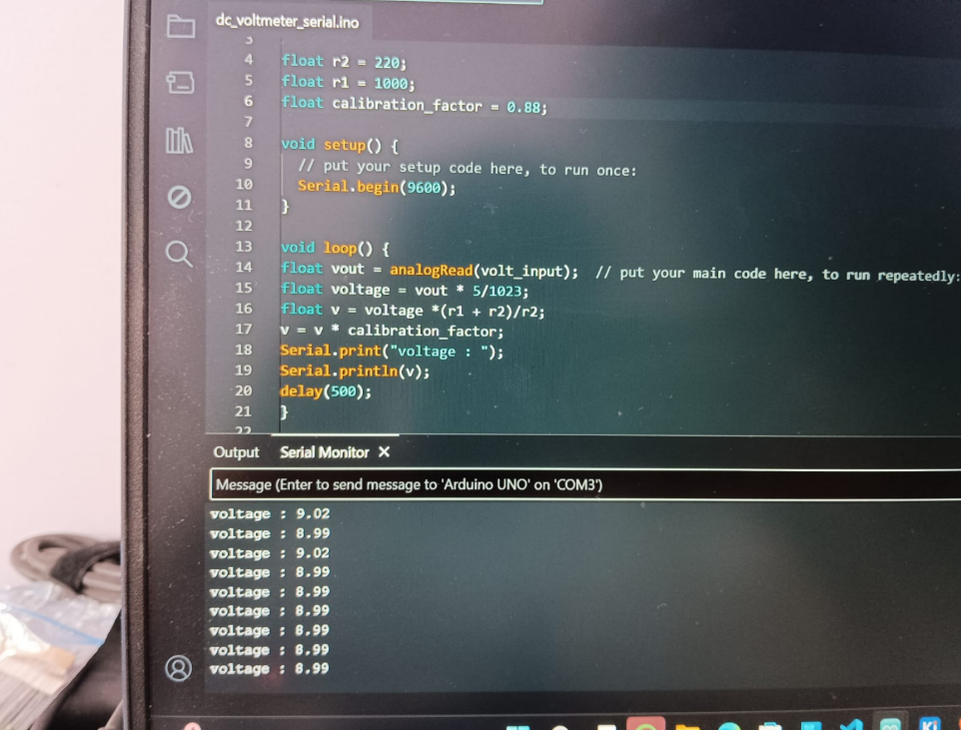
Project – 3(Temperature monitoring system)
Aim – To design and build the temperature monitoring system using Arduino and the dht / LM35 sensor and display real time temperature

Components required –
- Arduino Uno
- Temperature Sensor (LM35 / DHT11)
- Breadboard / PCB
- Connecting Wires

Working –
- The temperature sensor (LM35/DHT11) detects ambient temperature.
- LM35 outputs an analog voltage proportional to temperature.
- Arduino reads this value using an analog pin.
- The value is converted into temperature (°C).
- The result is displayed on LCD or Serial Monitor.

Schematic Diagram
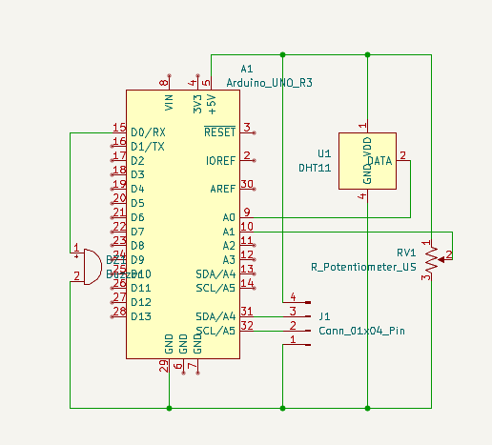
PCB Layout –
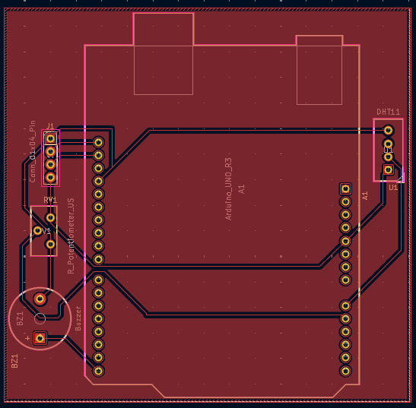

Main Coding Concepts
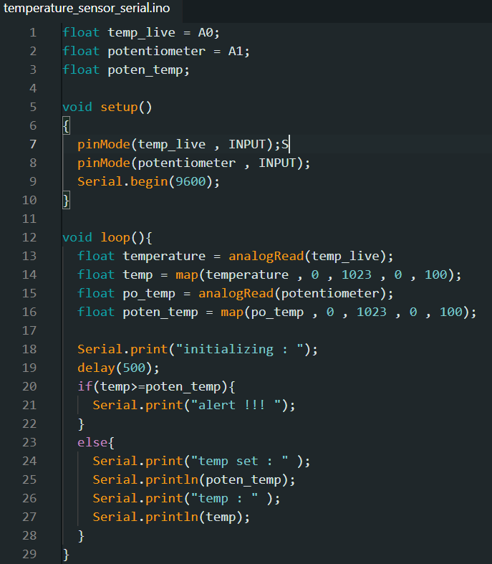
- The input from the potentiometer and the temperature sensor is taken
- Serial monitor is initialized
- The range of the temperature analog input and the potentiometer analog input is set
- Placing the if else condition
- If the sensor temperature is more than the potentiometer limit then sent alert , other wise keep displaying the temperature

Result –
The project successfully measures and displays temperature using Arduino and a temperature sensor, demonstrating a simple and effective monitoring system.
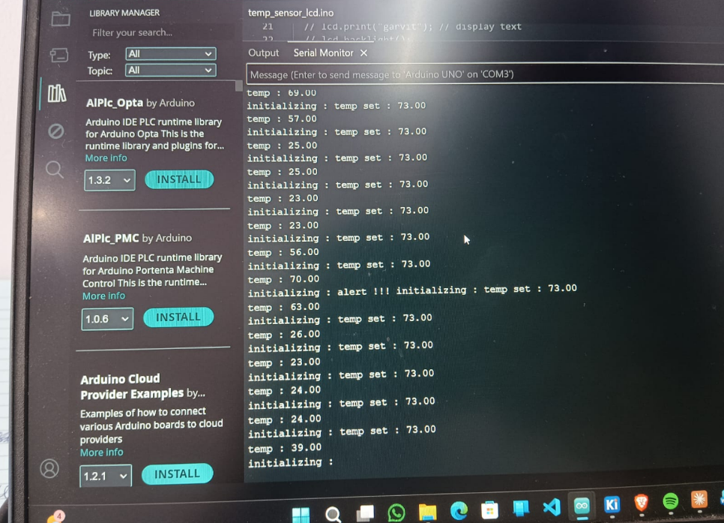
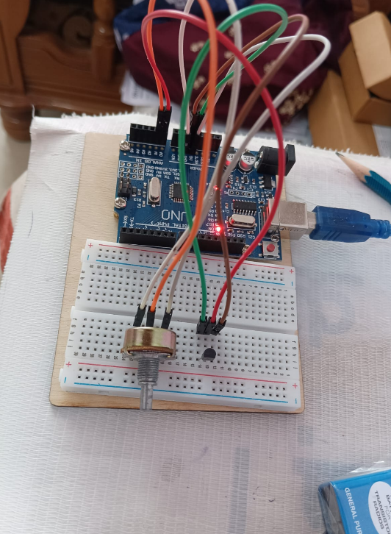
Project – 4 (Metal Detector)
Aim – To design and implement a metal detector using Arduino to detect the presence of metallic objects.

Components Required –
- Arduino Uno
- Coil (Inductor)
- Capacitor
- Buzzer
- Resistors
- Breadboard / PCB
- Connecting Wires

Working –
- A coil is used to generate a magnetic field when current flows through it.
- When a metal object comes near the coil, it disturbs the magnetic field.
- This change affects the circuit parameters (inductance/frequency).
- Arduino detects this variation and triggers a buzzer as an alert.

Schematic Diagram –
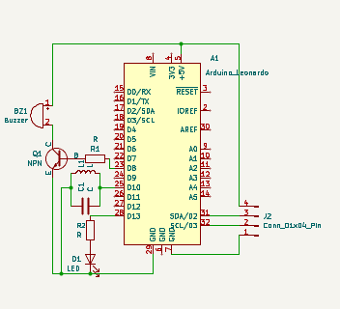

PCB Layout –
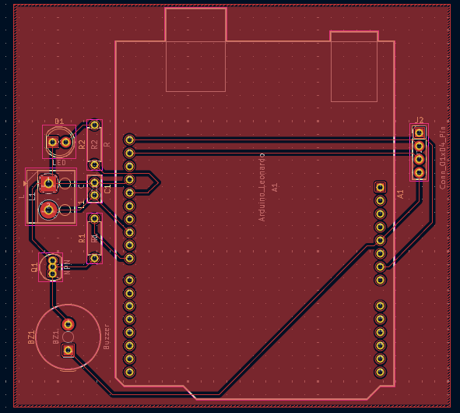

Main Coding Concepts –
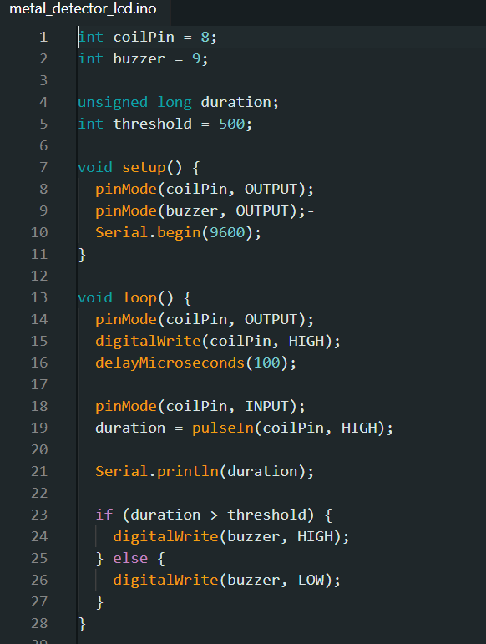
- Arduino monitors the signal from the detection circuit
- Detects change in frequency or voltage
- If change exceeds threshold → activates buzzer

Result –
The project successfully demonstrates detection of metal objects using electromagnetic principles and Arduino, providing a simple and effective detection system.

